COVID-19, Social Distancing, and Flattening the Curve… What Does This Have to do with Math?

Day | Total Infected
1 | 1 (you)
2 | 2 (you and friend)
3 | 4
4 | 8
5
6
7
8
9
10
11
12
13
14
- This coronavirus is highly contagious and easily spread. Let’s say hypothetically, you were the only person at Bear Creek that had the virus on Friday, the last day we were together. Saturday, you hung out with a friend, and they got the virus from you. Sunday, you and your friend each had a family dinner, with your grandparents (in their 60s, and therefore highly vulnerable) and they got the virus. Monday, everyone went out of the house, and infected someone they were in contact with.

This is a perfect example of Exponential Growth.

If you did not practice Social Distancing, how many people would be infected by you alone in just 2 weeks?

Be prepared to answer this question on the Google Form

2. Flattening the Curve – AREA!
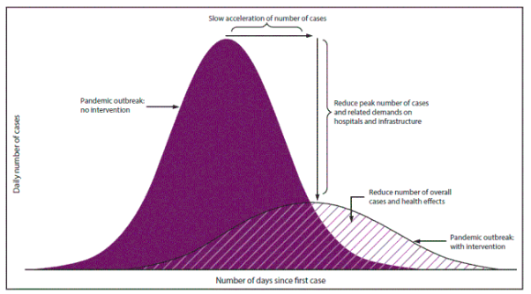

“Flattening the curve refers to community isolation measures that keep the daily number of disease cases at a manageable level for medical providers”

Here is an interactive article that illustrates Exponential Growth and Flattening the Curve
https://www.washingtonpost.com/graphics/2020/world/corona-simulator/

What does this have to do with area?
What are you doing to practice Social Distancing and Flattening the Curve so we can get back to normal life?
Be prepared to answer these questions on the Google Form

