HW#4 Trigonometry Word Problems Name
HINT – Draw a triangle for each problem
- Marshall rides a horse 70 feet down a straight slope from the top to the bottom of a hill. The slope makes a 39 degree angle to the flat ground. How many feet tall is the hill?

- Ethan stands 24 feet from a tree. He places a straight stick on the ground at his feet, angles it up until it points to the top of the tree, and measures the angle as 41 degrees. How many feet tall is the tree?

- Tyler is flying a kite and it gets stuck in a tree. He is standing 13 feet from the base of the tree. His kite string forms an angle of 36 degrees with the ground. How much string did he have let out when the kite hit the tree?

- While shopping at his local home improvement store, Chen notices that the directions for an extension ladder state, ”This ladder is most stable when used at a 75º angle with the ground.” He wants to buy a ladder to paint a two-story house that is 26 feet high. How long does his ladder need to be?

- A person standing on a 340ft cliff is watching a ship sail in. The ship is at a 62º angle of depression. Draw and label triangles for each part below.
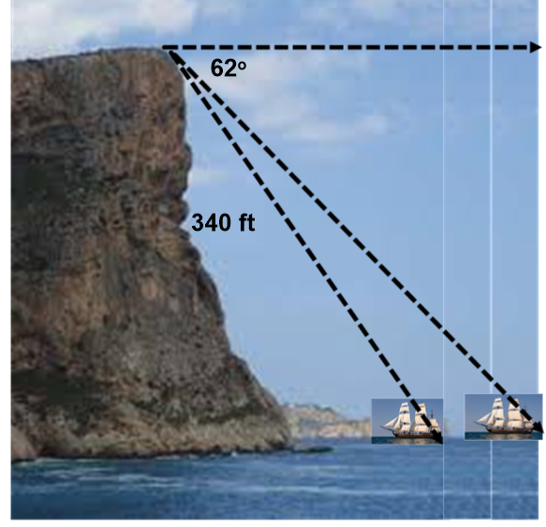
              - How far was the ship from the base of the cliff?

  - After 5 minutes, the ship is 112 feet from the cliff. What is the angle of elevation to the top of the cliff?

  - How far did the ship sail in that 5 minutes?

- Find the missing side lengths.
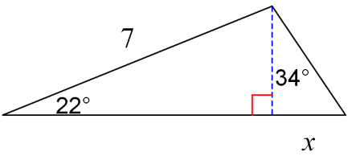
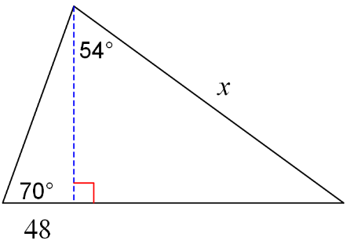
a. b.

- A scuba diver is at the end of a 400ft rope tied to a boat at an angle of 68o
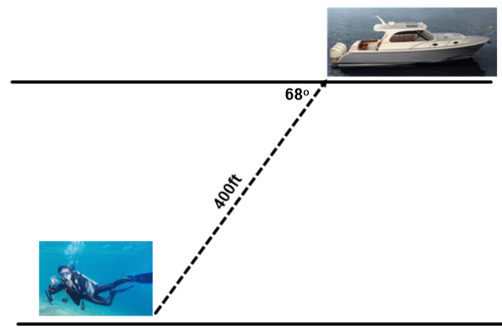
a. How far is the scuba diver below the surface
of the ocean?

- How far is the scuba diver behind the ship?

- If the rope is 500 feet, and the diver is at a depth of 300 feet, what is the angle of elevation from the diver to the boat?

