Name:
Period:_____
You are given the following spinner numbered 1 through 8 evenly spaced
1
2
3
4
5
6
7
8

1) If you spin the spinner once, what is the probability that you will spin:

- P(6) ______
- P(a multiple 3 or 4 ) ______
- P( a number less than 4) _______
- P( 10) ______
- P(a one-digit number ) _______
- P( even or a “5”) ________
- P(multiple of “3” and a number less than 5) _______

2) A basketball player made 15 out of her last 21 free throws.

- What is the probability she will make her next free throw?

- If she attempts 189 free throws for the season, how many free throws is she likely to make?

c) Will the number of free throws she actually makes match your prediction? Why or why not?

A bowl of M&M’s contains 12 reds, 9 greens, and 14 yellows. Find the probability of each of the following:

3) If you pick one M&M, find:

- P( green)

- P (not a red)

- P (red or green)

- P( green and yellow)

4) If you pick one M&M, eat it, then pick another one, find:

- P( red then green)

- P (both green)

- If both M&Ms are the same color, which color is the most likely? What is the probability that they are both this color?

5) Kevin has a spinner that has 5 equal sections on it. One section is colored green, one section blue, one section red, one section purple and one section black. He spins the spinner 80 times and gets the following results:

Color on the spinner | green | blue | red | purple | black
Frequency | 20 | 18 | 14 | 15 | 13

a) What is the theoretical probability that the spinner will land on blue?

b) Based on these experimental results in the table above, what is the probability the spinner will land on blue?

c) What is the theoretical probability that the spinner will land on green?

d) Based on these experimental results in the table above, what is the probability the spinner will land on green?

e) What would you expect to happen to the experimental probability if you conducted more spins?

6) Below are the number of students who play sports at a local high school. If one person is selected at random, find the following probabilities:

 | Basketball | Volleyball | Swimming | Track | Total
Female | 38 | 63 | 22 | 31
Male | 29 | 45 | 35 | 28
Total

a. P(female) b. P(swimming) c. P(female and track)

d. P(male or volleyball) e. P(basketball given that he’s male)

f. P(swimming or volleyball)

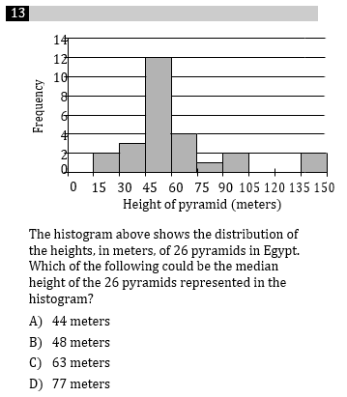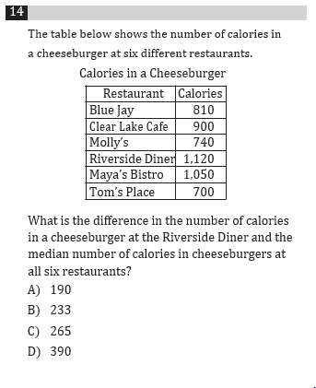

9. Your group of friends scored 68, 95, 72, 75, and 81 on a test. Find the following:

- Mean:

- Median:

- Range:

- How many scored above the mean?

10. Below is are histograms showing test scores for two different classes.

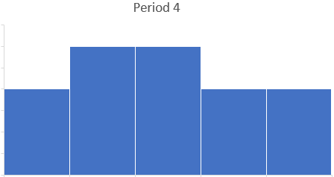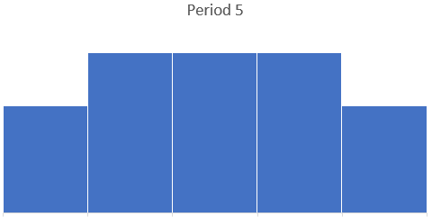
55 65 75 85 95 55 65 75 85 95

a. Which class has the greatest median? Explain.

b. Which class has the greatest range? Explain.

11. Below is are box and whisker plots showing test scores for two different classes.
The top graph is period 6, and the bottom graph is period 7.

a. Which class has the greatest median? Explain.

b. Which class has the greatest range? Explain.

55 75 95

12. A teacher raised student test scores by adding 10 points to each person’s score.

- Explain how that effects the class mean.

- Explain how that effects the class range.

