**Unit 9 Test Review – Area** Name: ___________________________________ Per: _____

|  |  |  |  |  |  |
| --- | --- | --- | --- | --- | --- |
| **Triangle** | **Parallelogram** | **Regular Polygon** | **Kite or Rhombus** | **Circle** | **Trapezoid** |
| **area, circumference, apothem, base, =diagonal, , perimeter, radius** | | | | | |

1. Find the area of each figure. Round to the tenths place.

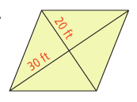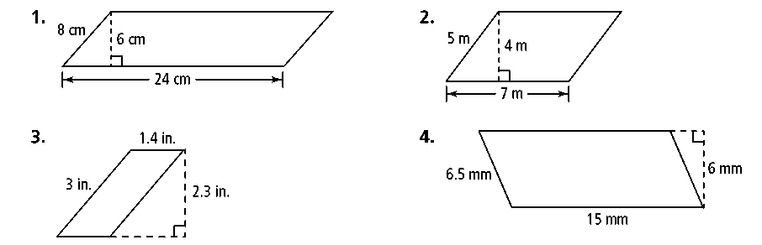a. b.

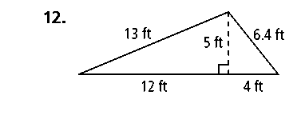c. d.

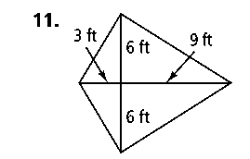

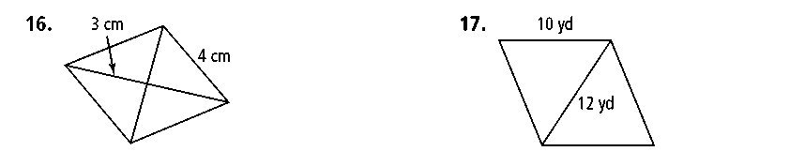

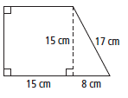

e. f.

g. (Optional – Extra Credit) h. (Optional – Extra Credit)

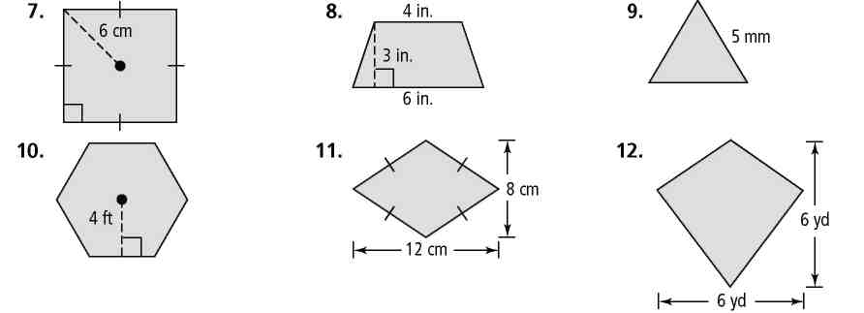

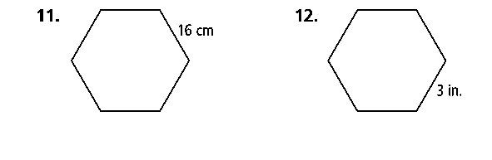

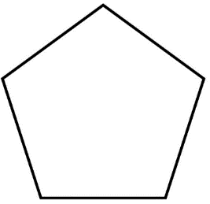2. A stage is a regular pentagon with side lengths of 8 meters and an apothem of 2.9 meters. What is the area of the stage? Hint: label your pentagon with what you know.

3. The area of a trapezoid is 48 ft2. It has a base of 5 and a base of 7. What is the height of the trapezoid? Draw a picture.

4. The area of a trapezoid is 60 ft2. It has a base of 18 ft and a height of 4 ft. What is the length of the second base? Draw a picture.

5. A garden is in the shape of a square. The farmer wants to increase one side by 3 ft and the other side by 5 ft and have a final area of 80 ft2.

1. What are the 2 possible solutions for x? (Hint: Label the original side lengths as “x”. Draw a picture of how he wants to increase the garden size.)
2. What is the original length of the square?
3. What are the new dimensions of the garden?

6. You want to find the area of the frame around a picture. Write a polynomial expression to represent the area of the frame. (Simplify, but do not solve!)

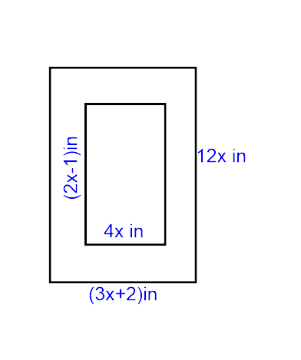

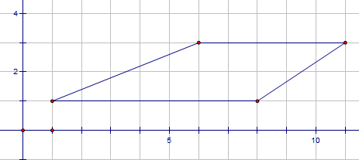7a. What is the shape in the diagram? __________________

b. What is the area of the shape? ________

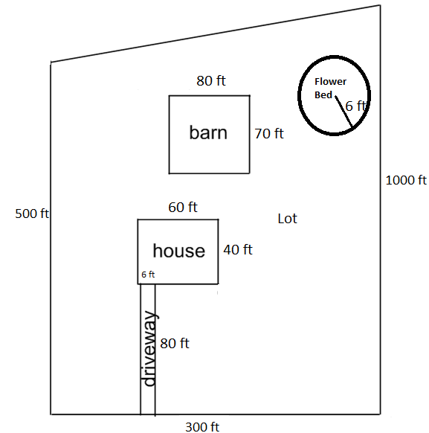8a. Joe bought a plot of land in the shape of a trapezoid. If he wants to plant grass everywhere on the lot that is not currently being used, how much grass will he need to plant?

b. If grass seed costs $2.98 per square foot, how much will this cost?