**Find the measure of each arc in *B.***

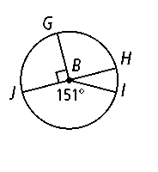**1.** **2.** **3.** 

**4.** **5.** 

**Find the length of each darkened arc. Leave your answer in terms of π*.***

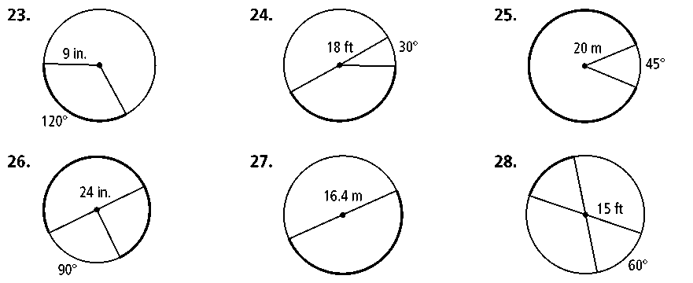 **6. 7.**

**Find the area of each shaded sector of a circle. Leave your answer in terms of π.**

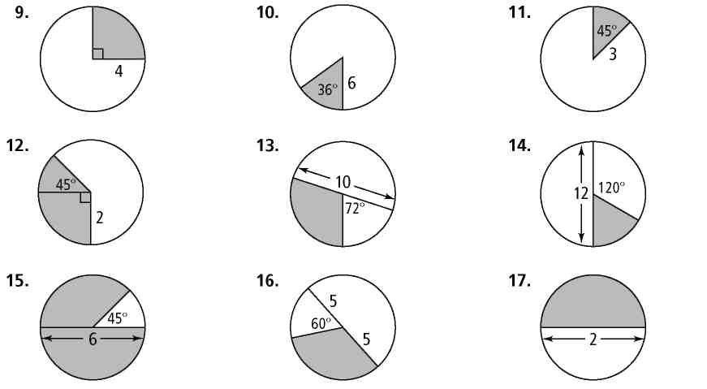 **8. 9.**

**Assume that lines that appear to be tangent are tangent. *O* is the center of each circle. What is the value of *x?***

|  |  |  |
| --- | --- | --- |
| **10.** | **11.** |  |

**Determine whether a tangent line is shown in each diagram. Explain**.

|  |  |  |
| --- | --- | --- |
| **12.** | **13.** |  |

**In each circle, what is the value of *x* to the nearest tenth?**

|  |  |  |
| --- | --- | --- |
| **14.** | **15.** |  |

**Each polygon circumscribes a circle. What is the perimeter of each polygon?**

|  |  |
| --- | --- |
| **15.** | **16.** |

**Find the value of *x.***

|  |  |  |
| --- | --- | --- |
| **17.** | **18.** | **19.** |

**Find the value of *x* to the nearest tenth.**

|  |  |  |
| --- | --- | --- |
| **20.** |  | **21.** |