**Unit 11 Test Review Name: __________________ Period:________**

**Find the volume of each figure. Round your answer to the nearest tenth. When possible, give your answer in terms of pi and to the nearest tenth. HINT: SHADE IN YOUR BASES.**

|  |  |  |  |
| --- | --- | --- | --- |
| **1.**  **Type of figure: _______________**  **Shape of base: _______________**  **Area of base: ________________**  **Volume: ________________** | **2.**  **Type of figure: _______________**  **Shape of base: _______________**  **Area of base: ________________**  **Volume: ________________** | | **3.**  **Type of figure: _______________**  **Shape of base: _______________**  **Area of base: ________________**  **Volume: ________________** |
| **4.**    **Type of figure: _______________**  **Shape of base: _______________**  **Area of base: ________________**  **Volume: ________________** | **5.**    **Type of figure: _______________**  **Shape of base: _______________**  **Area of base: ________________**  **Volume: ________________** | | **6.**  **Type of figure: _______________**  **Shape of base: _______________**  **Area of base: ________________**  **Volume: ________________** |
| **7.**  **Type of figure: _______________**  **Volume in terms of** :__________  **Volume to the nearest hundredth: ________________________** | **8.**  **Type of figure: _______________**  **Volume in terms of** :__________  **Volume to the nearest hundredth: ________________________** | | 1. Types of figures__________   _______________________  Volume (in terms of _________  (nearest 10th) _____________________ |
| **10. A spherical scoop of ice cream with a diameter of 4 cm rests on top of a sugar cone that is 10 cm deep and has a diameter of 4 cm. If all the ice cream melts into the cone, what percent of the cone will be filled?** | | | 11. Find the volume. | | |
| **12.** A cylinder, a cone, and a sphere have the dimensions indicated in the diagram below.  **a.** What are the formulas for the volume of the cone and the volume of the cylinder in terms of *r?* Express each answer in terms of π.  **b.** If *r* = 9 in., what are the volumes of the cone, cylinder, and sphere?  **c.** How are the volumes related? | | | | | |
| 13. Mike needs to buy a water tank for his business. The tank must fit inside a storage box that is shaped like a cube with side lengths of 10 feet. Water tanks are available in cylinders, and spheres. Mike wants to buy the tank that has the largest capacity.    Find the volume of the largest possible sphere-shaped water tank.  Find the volume of the largest possible cylinder-shaped water tank.  What shape of tank should Mike buy? Answer: __________________ | | | | | |
| 14. Suppose you revolve the plane region completely about the the x-axis to create a 3-D figure. State the solid that would be formed. Then find its volume in terms of .  Figure formed ___________  Volume(in terms of )______ | | | | | |

15. A size 7 basketball has a circumference of 29.5 inches. What is the volume of the basketball in cubic inches?

16. The volume of a cone is 32cubic feet. The height of the cone is 6 feet. What is the radius of the cone?

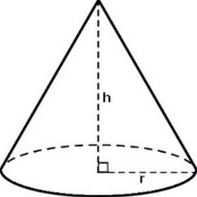

Radius of the cone ______

17. The volume of a cylinder is 150cubic inches. The length of the radius is 5 inches. What is the height of the cylinder?

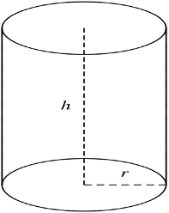

Height of the cylinder ________

18. What happens to the volume of a square-based pyramid when the edge of the base is tripled? Show examples as evidence of your claim.

