HW#1 p. 654 #13-23 odd, 25, 29, 31
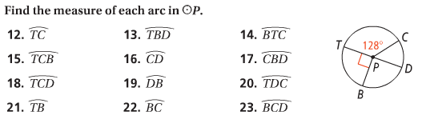
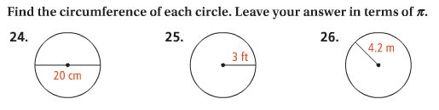
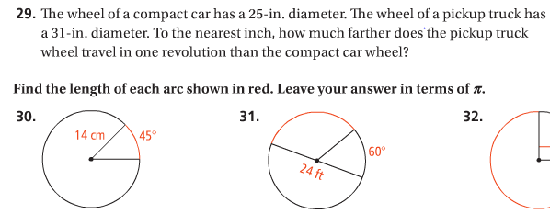

HW#2 p. 663 #7, 9, 13-17 odd
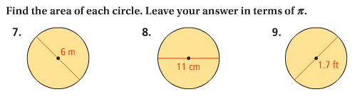
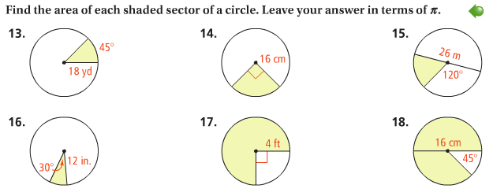

HW#3 p. 767 #6-9, 13, 15-19
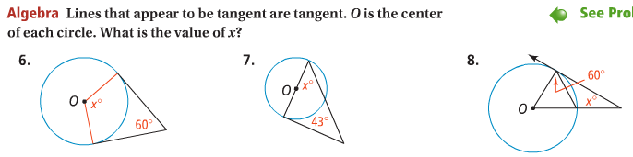
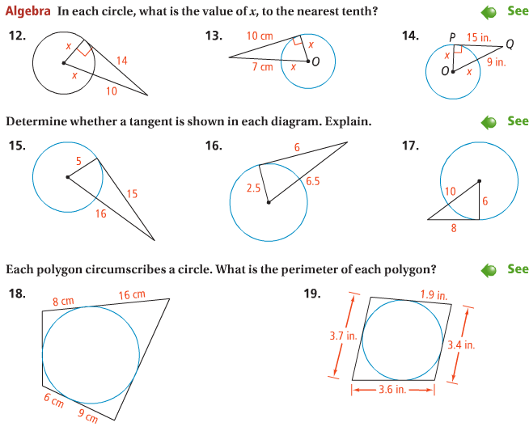

HW#4 p. 776 #8-10, 13-15,23,25
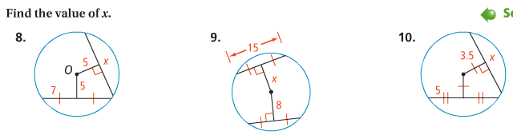
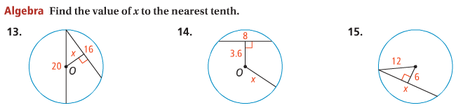
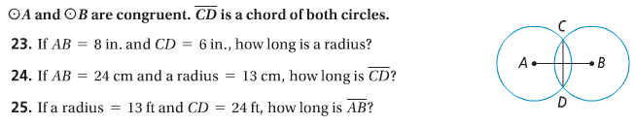

HW#5 p. 784 #7-17 odd, 20, 21-25 odd
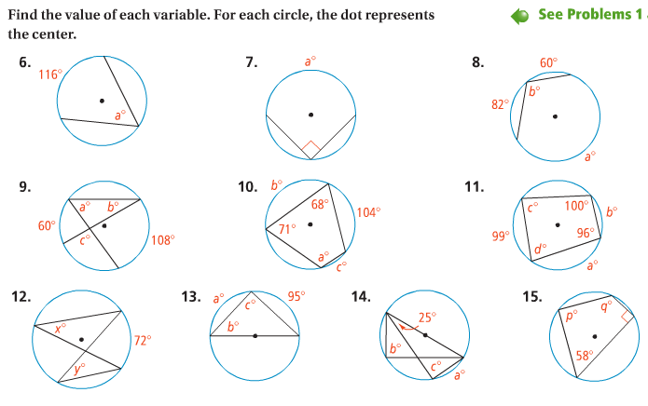
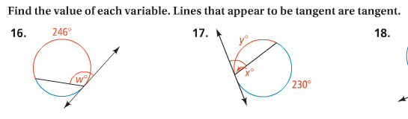
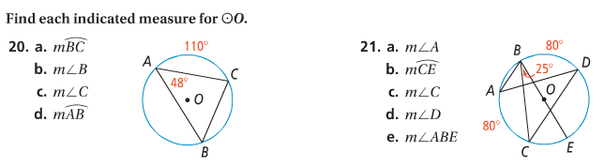
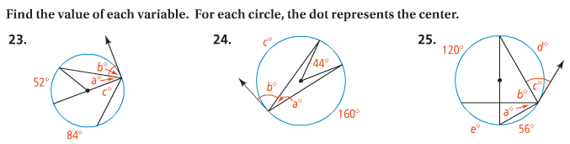
HW#6 p. 801 #13-21 odd, 25, 27, 31-39 odd
