HW#1 P436 #9, 13-21 odd, 25, 26, 41, 43
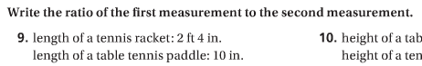
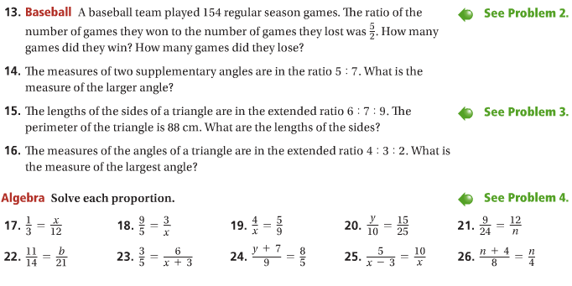
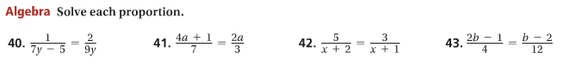

HW#2 p444 #9, 11, 14, 15, 17-20, 32, 37, 38
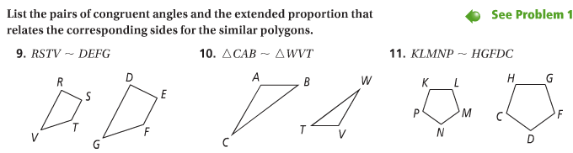
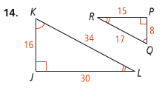
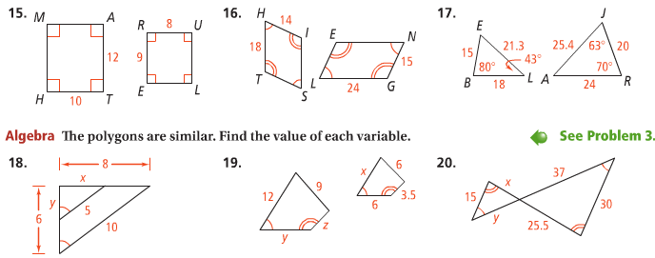
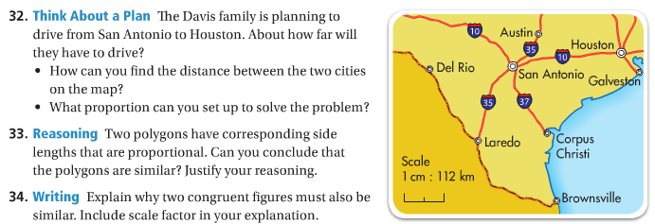
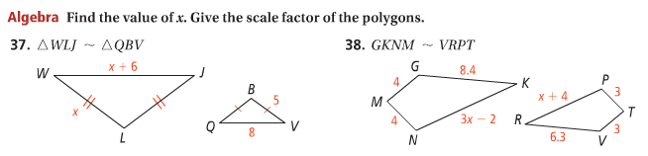

HW#3 p455 #7-12, 15-16, 22, 23, 24
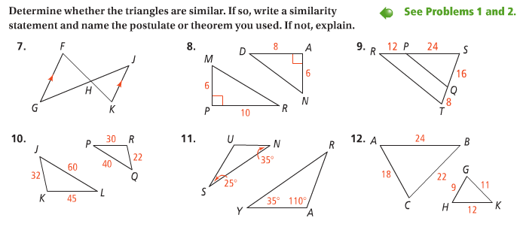
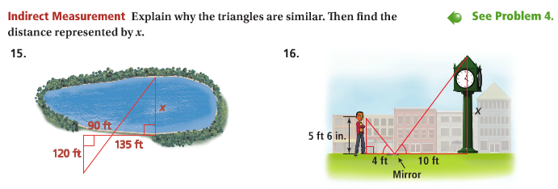
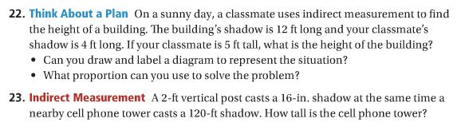
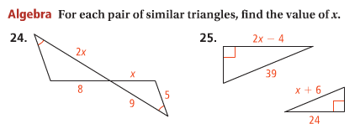
HW#4 p475 #9-21 odd, 31, 32
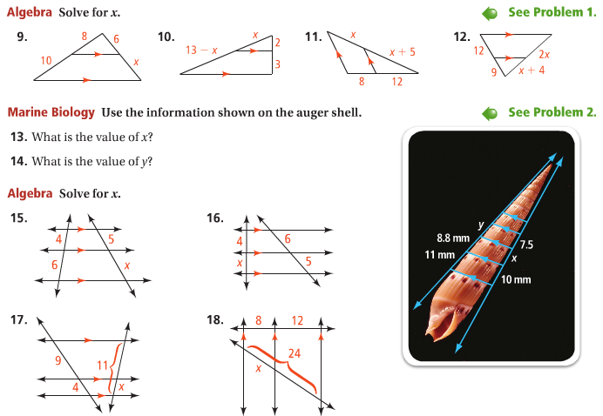
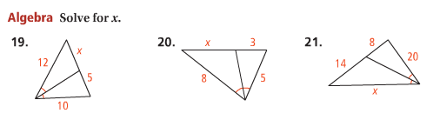
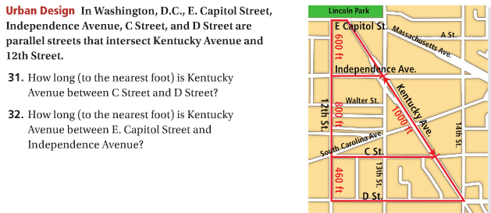
HW#5 p578 #9-15 odd, 16, 18, 29, 31, 33, 37, 38, 49-52
