HW#1 p619#8-18, 41-43 skip 11-13
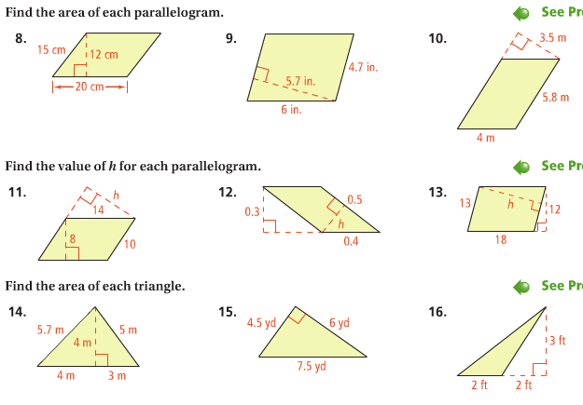
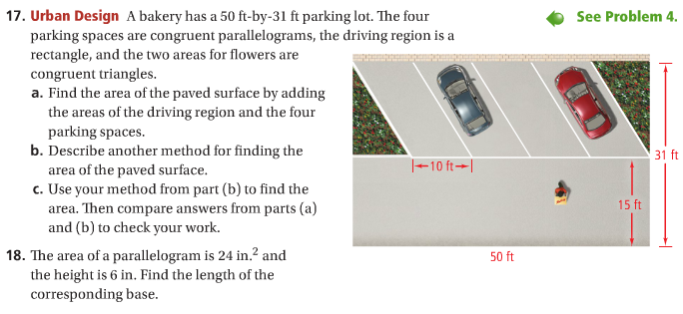
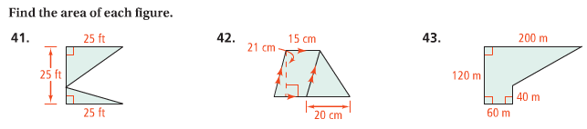
HW#2 p626#11-14, 17-25, 30,31 17-19, 23-25, 30, 31 – use Pythagorean Theorem or Trigonometry
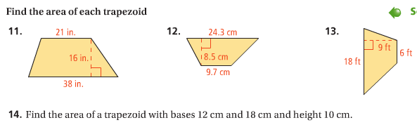
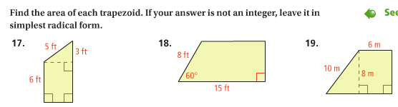
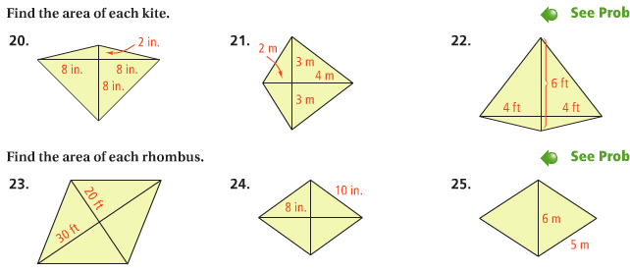
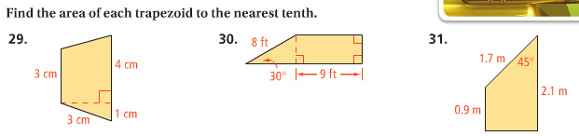

HW#3 p632#11-14, 31, 32 (17-19, 22,23,33- optional – extra credit)
