**Unit 9—Circles Test Review Name: _________________ Geometry, p. ___**

1. Find the length of the shaded arc. 2. Find the area of the sector.

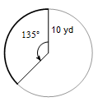

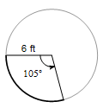

Answer in terms of ____________ Answer in terms of ____________

Answer to nearest 10th __________ Answer to nearest 10th __________

(one decimal place) (one decimal place)

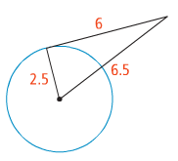3. Determine if the line $\overline{AB}$ is tangent.

a. b.

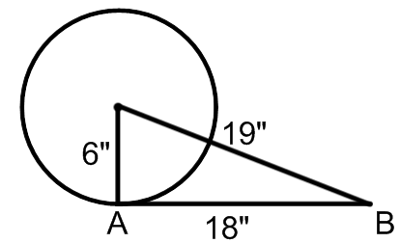

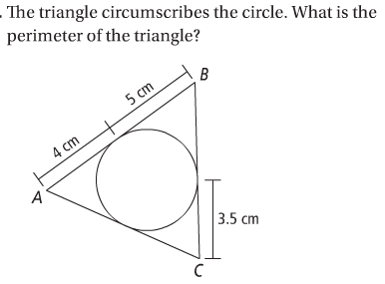4. a. b. The polygon circumscribes the circle. What

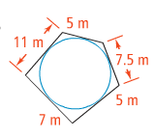 is the perimeter of the figure?

5. Find the value of each variable.

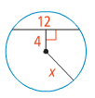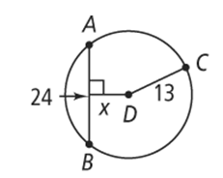

a. b.

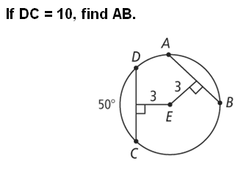

c. d. Find the radius of the circle.

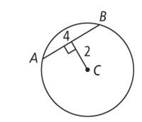

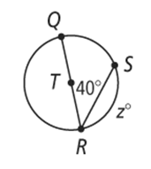6. Solve for x for the inscribed triangles. Round your answer to the nearest tenth.

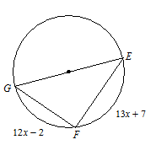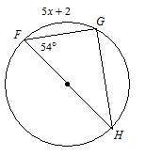a. b. c.

7. Find the value of each variable.

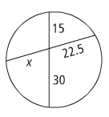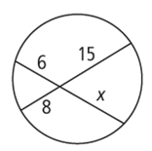

a. b.

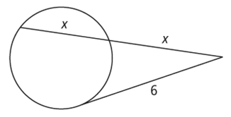8. Find the value of each variable.

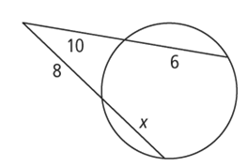a. b.

9. Find the value of each variable.

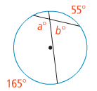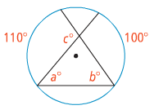

a. b.

10. Graph each circle. Label the center and radius.

a. b.

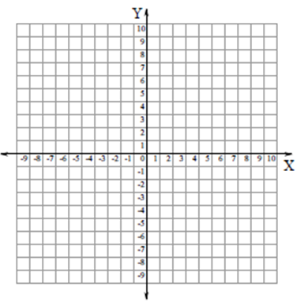

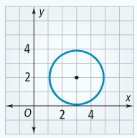11. Write the equation of the circle shown.

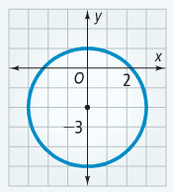a. b.

12. Write the equation of a circle that has a diameter with endpoinnts (2, 4) and (-4, 2)